

Department of Computer Science and Engineering
Semester: Fall 2023
Course Code: CSE 207
Course Title: Data Structures

Lab: 02
Submitted to
Md. Manowarul Islam
Adjunct Faculty, Department of CSE
Submitted by
Swarna Rani Dey
ID: 2022-1-60-340
Section: 7

Exercise -1
Code:
#include <stdio.h>
void addition(int mat1[50][50], int mat2[50][50], int matn[50][50], int
rows, int columns) {
for (int i = 0; i < rows; i++) {
for (intj = 0; j < columns; j++) {
matn[i][j] = mat1[i][j] + mat2[i][j];
}
}
printf("\nMatrix Addition:\n");
for (int i = 0; i < rows; i++) {
for (intj = 0; j < columns; j++) {
printf("%d", matn[i][j]);
}
printf("\n");
}
}
void subtraction(int mat1[50][50], int mat2[50][50], int matn[50][50],
int rows, int columns) {
for (int i = 0; i < rows; i++) {
for (intj = 0; j < columns; j++) {
matn[i][j] = mat1[i][j] - mat2[i][j];
}
}
printf("\nMatrix Subtraction:\n");
for (int i = 0; i < rows; i++) {
for (intj = 0; j < columns; j++) {
printf("%d", matn[i][j]);
}
printf("\n");
}
}
void multiplication(int mat1[50][50], int mat2[50][50], int mul[50][50], int rows, int columns) {
printf("Matrix Multiplication:\n");
for (int i = 0; i < rows; i++) {
for (intj = 0; j < columns; j++) {
mul[i][j] = 0;
for (int k = 0; k < columns; k++) {
mul[i][j] += mat1[i][k] * mat2[k][j];
}
}
}
for (int i = 0; i < rows; i++) {
for (intj = 0; j < columns; j++) {
printf("%d", mul[i][j]);
}
printf("\n");
}
}
int main() {
int mat1[50][50], mat2[50][50], matn[50][50], rows, columns, in,
mul[50][50];
printf("Enter the number of rows for the matrix: ");
scanf("%d", &rows);
printf("Enter the number of columns for the matrix: ");
scanf("%d", &columns);
printf("Enter the first matrix elements:\n");
for (int i = 0; i < rows; i++) {
for (intj = 0; j < columns; j++) {
scanf("%d", &mat1[i][j]);
}
}
printf("Enter the second matrix elements:\n");
for (int i = 0; i < rows; i++) {
for (intj = 0; j < columns; j++) {
scanf("%d", &mat2[i][j]);
}
}
printf("\n1 for addition\n");
printf("2 for subtraction\n");
scanf("%d", &in);
if(in== 1) {
addition(mat1, mat2, matn, rows, columns);
} else if (in == 2) {
subtraction(mat1, mat2, matn, rows, columns);
} else if (in == 3) {
multiplication(mat1, mat2, mul, rows, columns);
}
return 0;
}

Output:
Matrix Multiplication
12
12
12
ia
18
18
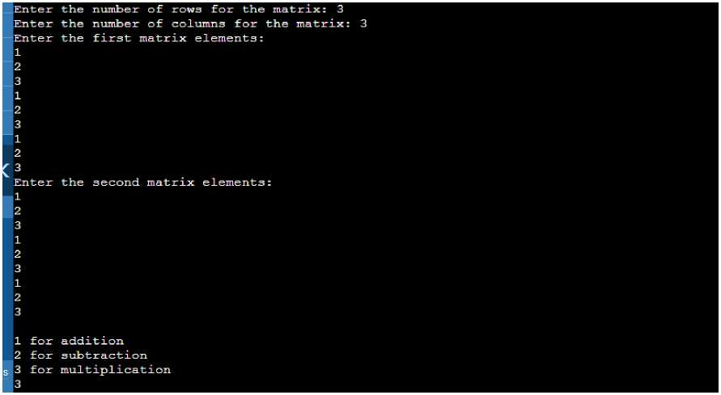

I.. .Program finished with exit code 0 Press ENTER to exit console.l

Exercise -2
Code:
#include <stdio.h>
int main() {
int mat[50][50], rows, columns, i, j, sum;
int choice;
printf("Enter the number of rows for the matrix:");
scanf("%d", &rows);
printf("Enter the number of columns for the matrix:"); scanf("%d", &columns);
printf("Enter the input for the matrix:\n");
for (i = 0; i < rows; i++) {
for (j = 0; j < columns; j++) { scanf("%d", &mat[i][j]);
}
}
printf("Choose the operation:\n");
printf("1. Sum of rows\n");
printf("2. Sum of columns\n");
scanf("%d", &choice);
if (choice == 1) {
printf("\nSum of rows:\n");
for (i = 0; i < rows; i++) {
sum = 0;
for (j = 0; j < columns; j++) {
sum += mat[i] [j];
}
printf("Row %d: %d\n", i + 1, sum);
}
} else if (choice == 2) {
printf("\nSum of columns:\n");
for (i = 0; i < columns; i++) {
sum = 0;
for (j = 0; j < rows; j++) { sum += mat[j][i];
}
printf("Column %d: %d\n", i + 1, sum);
}
} else {
printf("Invalid choice.\n");
}
return 0;
}

Output:
lEnter the number of rows for the matrix: 3
[Enter the number of columns for the matrix: 3
[Enter the input for the matrix:
1
2
3
4
5
6
7
3
9
Choose the operation:
■1. Sum of rows
2. Sum of columns
2
Sum of columns:
lcolumn 1: 12
lcolumn 2: 15
Column 3: 18
1
Sum of rows:
Row 1: 6
Row 2: 15
Row 3: 24
...Program finished with exit code 0 Press ENTER to exit console.

Exercise -3

Code:
#include <stdio.h> int main() {
int row, col;
printf("Enter the number of rows and columns in the matrix: "); scanf("%d %d", &row, &col);
if (row <= 0 || col <= 0) {
printf("Invalid matrix dimensions.\n");
return 1;
}
int matrix[row][col];
printf("Enter the elements of the matrix:\n");
for (int i = 0; i < row; i++) {
for (intj = 0; j < col; j++) {
scanf("%d", &matrix[i][j]);
}
}
for (int i = 0; i < row; i++) {
int max_in_row = matrix[i][0];
for (intj = 1; j < col; j++) {
if (matrix[i][j] > max_in_row) {
max_in_row = matrix[i][j];
}
}
printf("Row %d: %d\n", i + 1, max_in_row);
}
for (intj = 0; j < col; j++) {
int max_in_col = matrix[0][j];
for (int i = 1; i < row; i++) {
if (matrix[i][j] > max_in_col) {
max_in_col = matrix[i][j];
}
}
printf("Column %d: %d\n", j + 1, max_in_col);
}
return 0;
}

Output:
_Enter the number of rows and columns in the matrix: 3
3
Enter the elements of the matrix:
1
2
3
4
5
6
7
3
' 9
Row 1: 3
■Row 2: 6
;Row 3: 9
Column 1: 7
Column 2: 8
Column 3: 9
...Program finished with exit code 0 Press ENTER to exit console.]

Exercise - 4

Code:
#include <stdio.h>
int main() {
int mat[10][10], rows, columns, i, j;
printf("Enter the number of rows and columns for the matrix: ");
scanf("%d %d", &rows, &columns);
printf("Enter input for matrix:\n");
for (i = 0; i < rows; i++) {
for (j = 0; j < columns; j++) {
scanf("%d", &mat[i][j]);
}
}
for (i = 0; i < rows; i++) {
for (j = i + 1; j < columns; j++) { inttemp = mat[i][j];
mat[i][j] = mat[j][i];
mat[j][i] = temp;
}
}
printf("\nThe transpose matrix is:\n");
for (i = 0; i < columns; i++) {
for (j = 0;j <rows;j++) { printf("%d", mat[i][j]);
if (j == rows - 1) { printf("\n");
}
}
}
return 0;
}

Output:
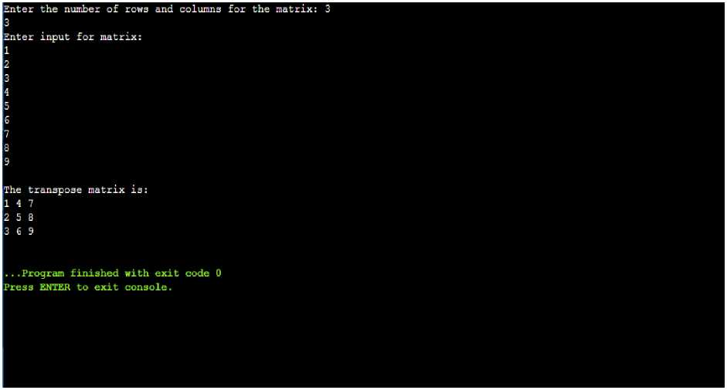

Exercise -5

Code:
#include<stdio.h>
int main()
{
int mat[10][10] ,matn[10][10] ,rows,columns,i,j;
printf("Enter the number of rows and columns for matrix:");
scanf("%d%d",&rows,&columns);
printf("Enter input for matrix=\n");
for (i = 0; i < rows; i++)
{
for (j = 0; j < columns; j++)
{
scanf("%d", &mat[i][j]);
}
}
printf("Diagonal of the Matrix=\n"); for(i=0; i<rows; i++)
{
for(j=0; j<columns; j++)
{
if(i == j)
{
printf("%d", mat[i][j]);
}
else{
printf("\t");
}
}
printf("\n");
}
}
Enter the nurnber of rows and columns for matrix:3 3
Enter input for matrix=

Diagonal of the Matrix=
1
. ..Program finished with exit code 0 Presa ENTER to exit console.|

Exercise -6

Code:
#include <stdio.h>
int main() {
int mat[10][10], rows, columns, i, j, isZeroMatrix = 1;
printf("Enter the number of rows and columns for the matrix: "); scanf("%d %d", &rows, &columns);
printf("Enter input for matrix:\n"); for (i = 0; i < rows; i++) {
for (j = 0; j < columns; j++) { scanf("%d", &mat[i][j]);
}
}
for (i = 0; i < rows; i++) {
for (j = 0; j < columns; j++) {
if(i==j&& mat[i][j] != 1) {
isZeroMatrix = 0;
break;
} else if (i !=j && mat[i][j] != 0) { isZeroMatrix = 0;
break;
}
}
if (isZeroMatrix == 0) { break;
}
}
if (isZeroMatrix == 1) { printf("The matrix is an IDENTITY MATRIX.");
} else {
printf("The matrix is not an IDENTITY MATRIX."); }
return 0;
}

Output:
^Enter the number of rows and columns for the matrix: 3 3
^Enter input for matrix:
11
0
0
0
■1
0
'0
0
1
The matrix is an IDENTITY MATRIX.
I...Program finished with exit code 0
Press ENTER to exit console.

